
educational flutter app
Assignment no 01

Submitted to: Sir Haris
Submitted by: Wasif Ali (245187)
BSCS F’24 4-B
Date: 04/03/2026
Course: Mobile Computing

Assignment 1 CLO-2
Requirements
- Contain minimum 5 Flutter topics
- Use TabBar or BottomNavigationBar
- Include animated explanation cards
- Show diagrammatic representation of concepts
- Include at least one working example per topic
- You can use any type of animations
Complete Output/Result:
Lesson 01:
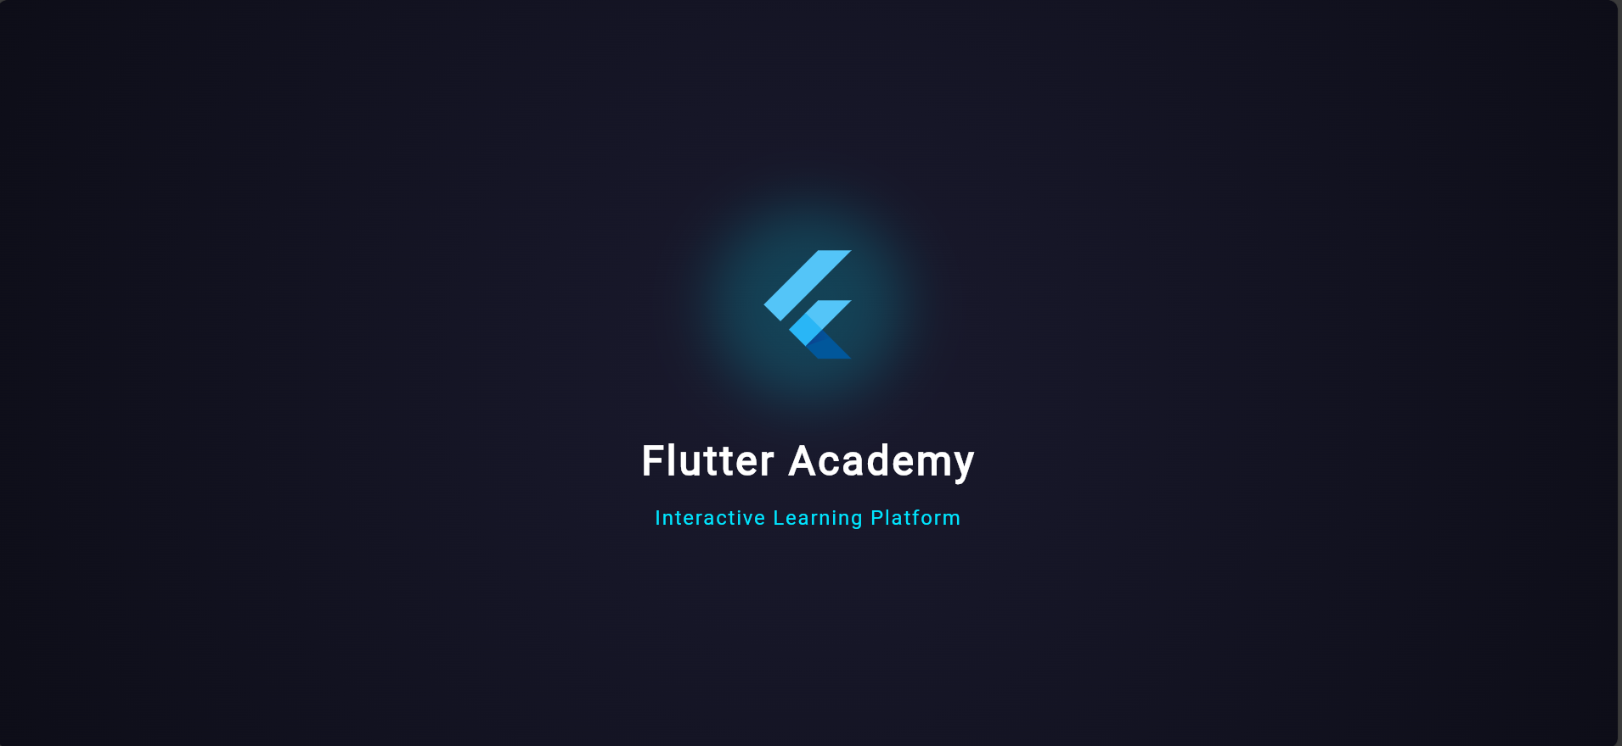
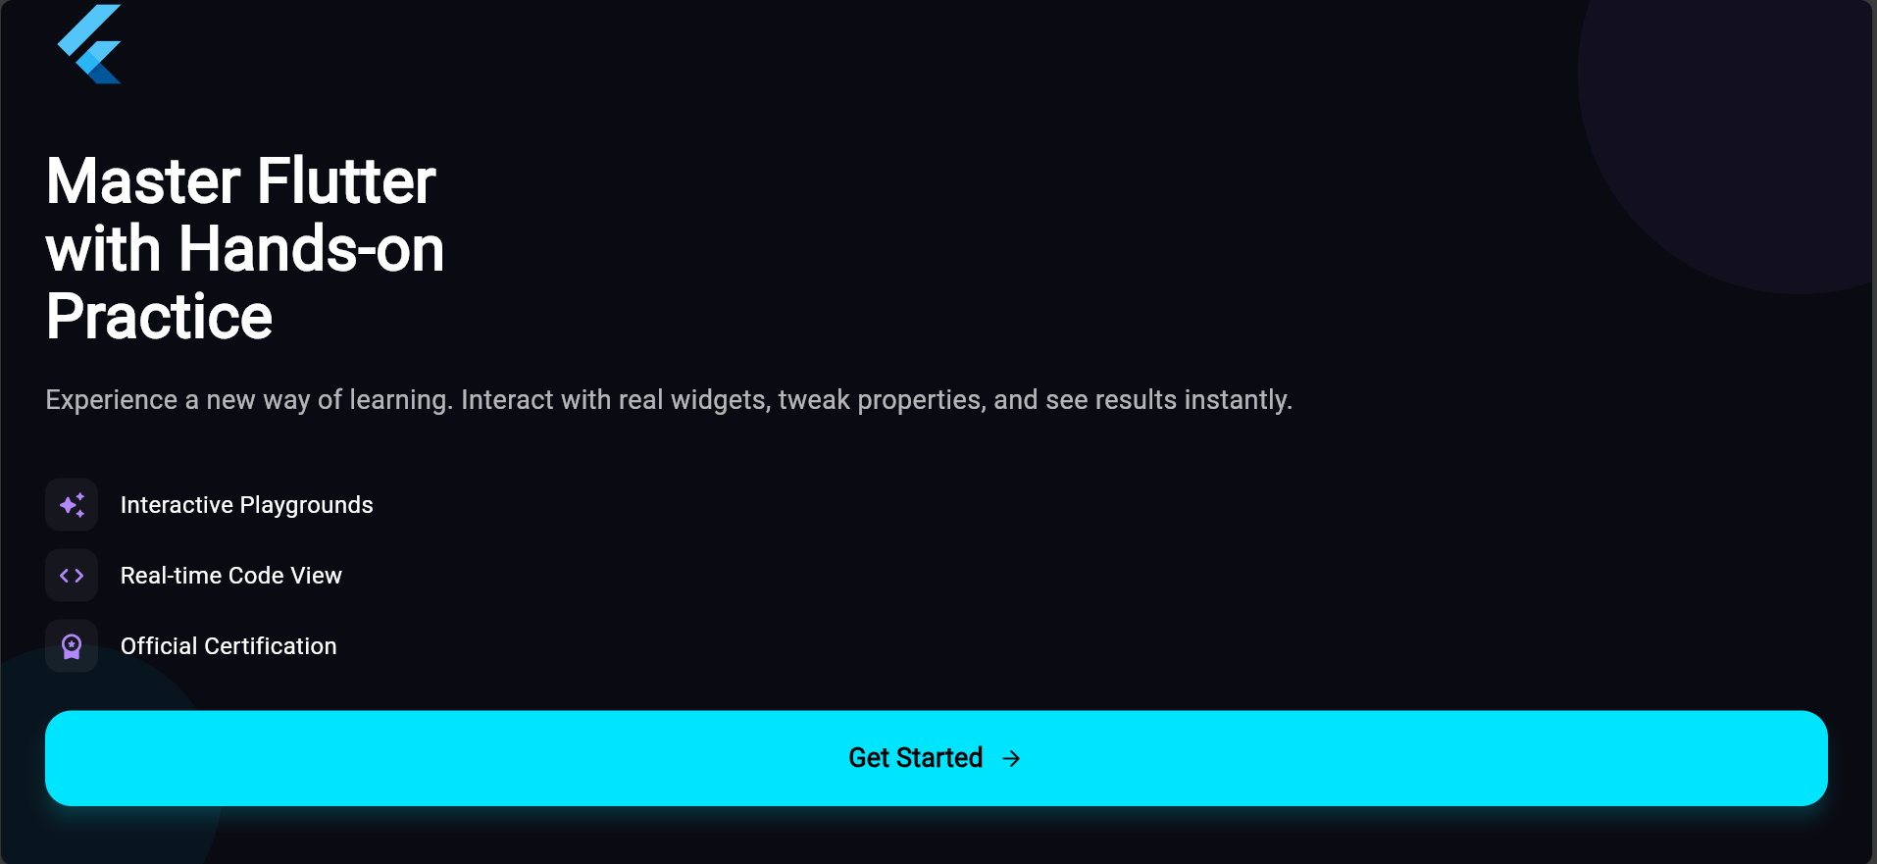
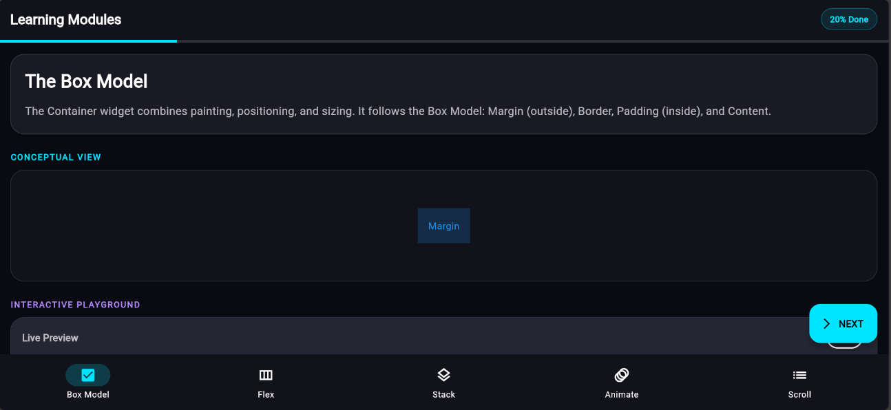

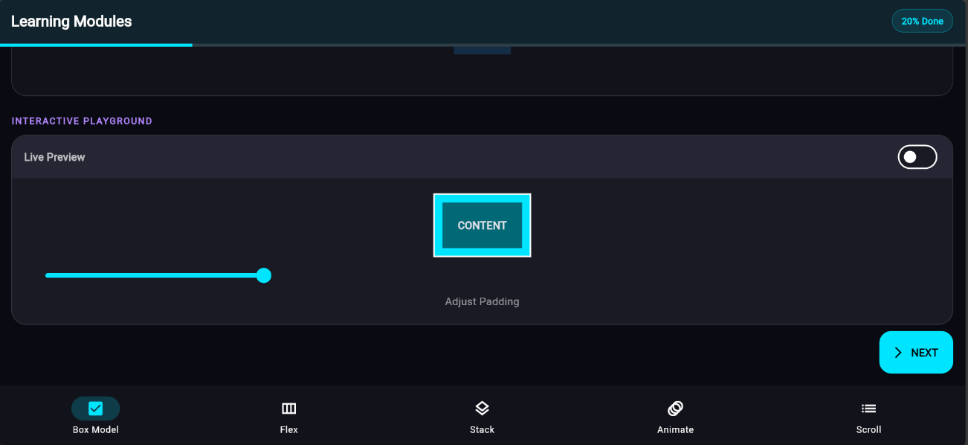

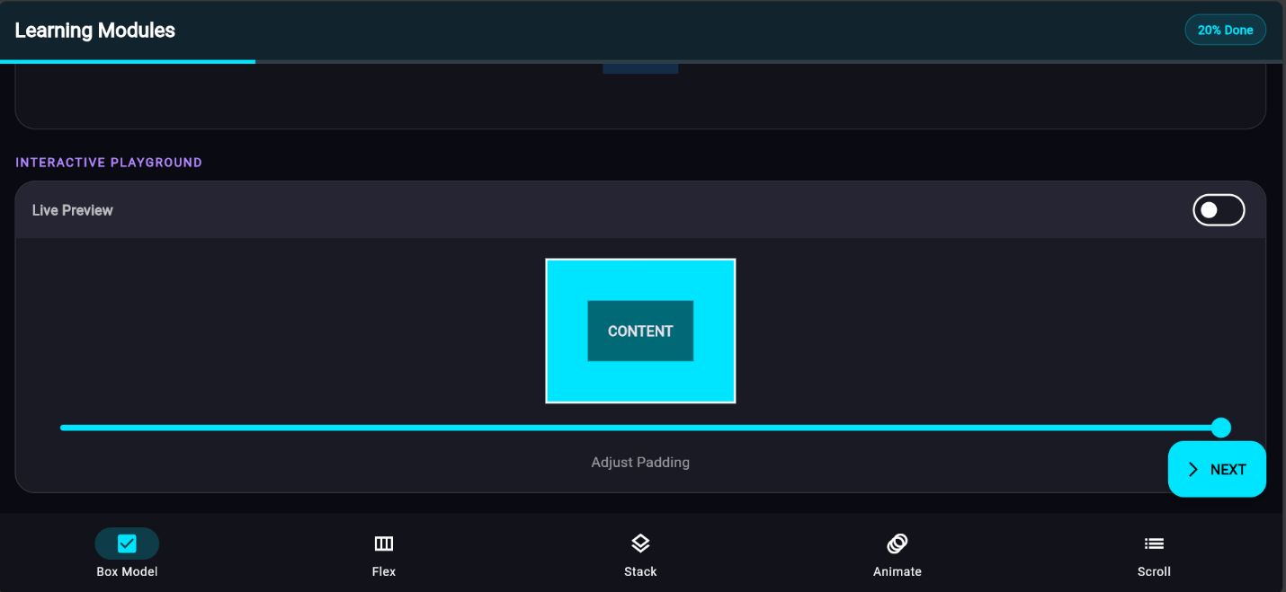

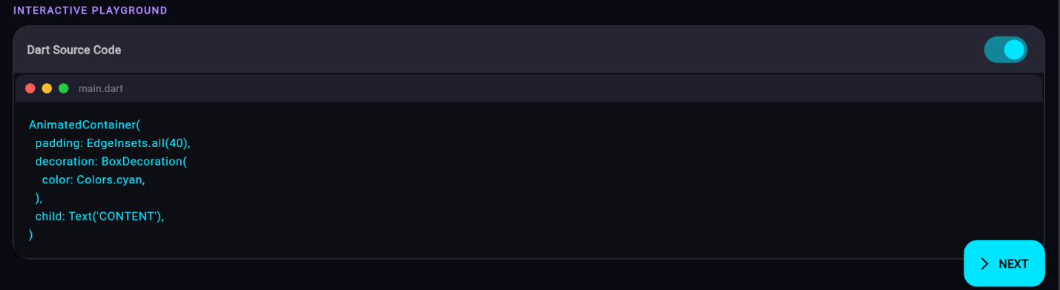

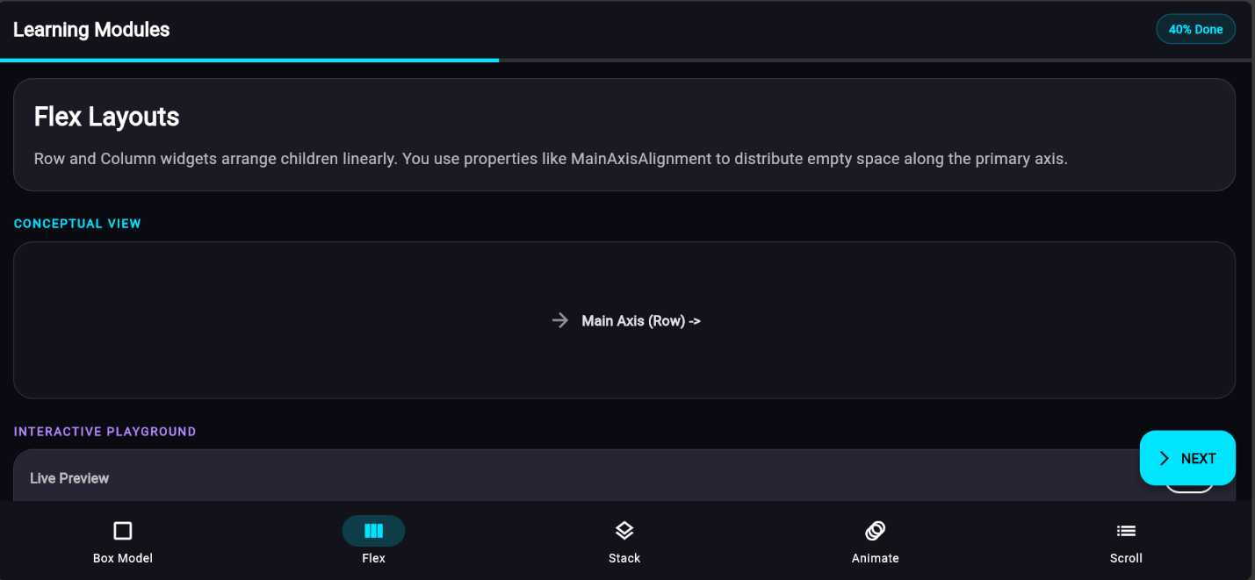
Lesson 02:

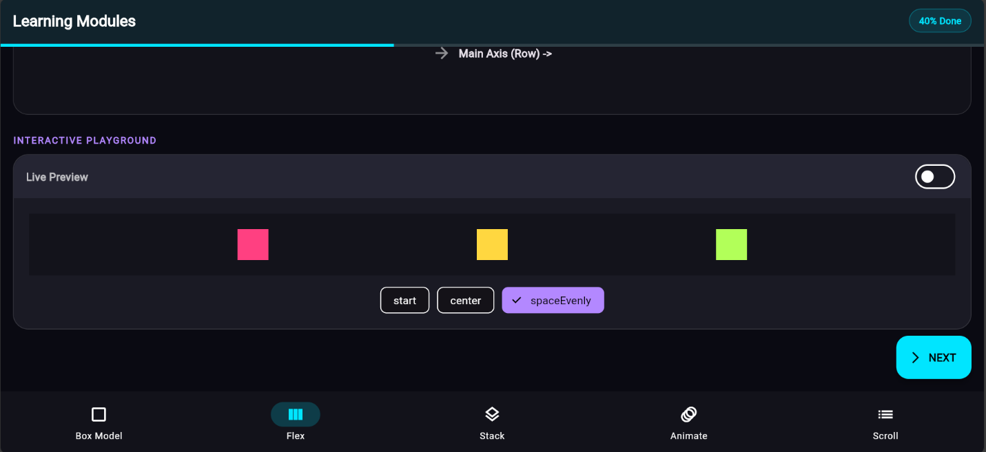

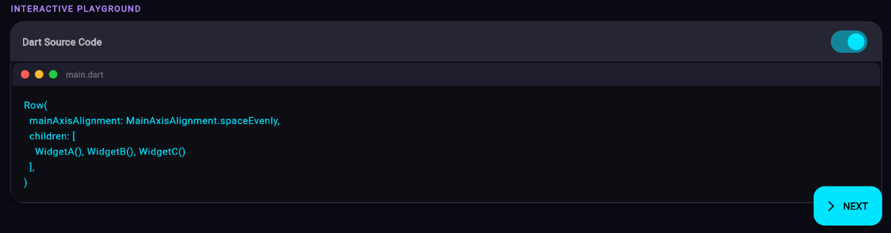

Lesson 03:
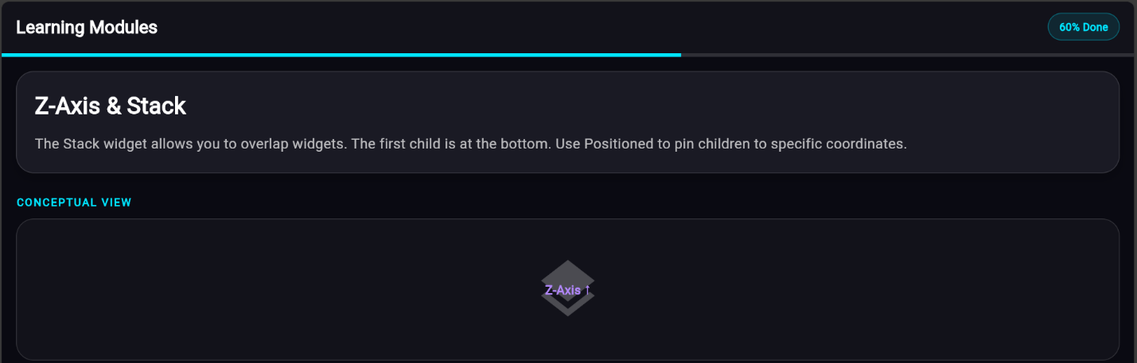

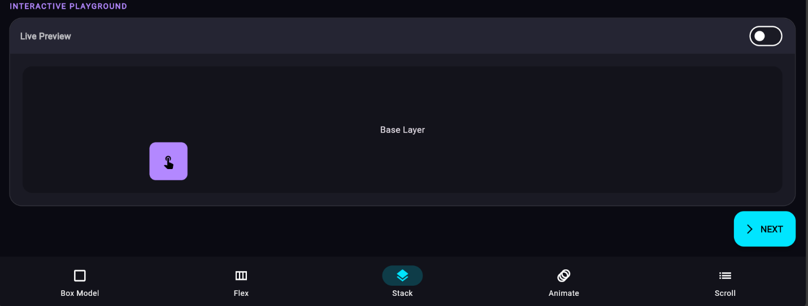

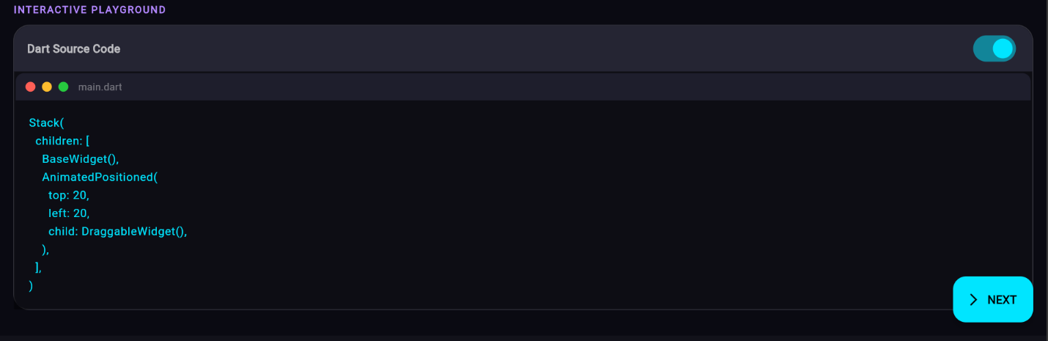

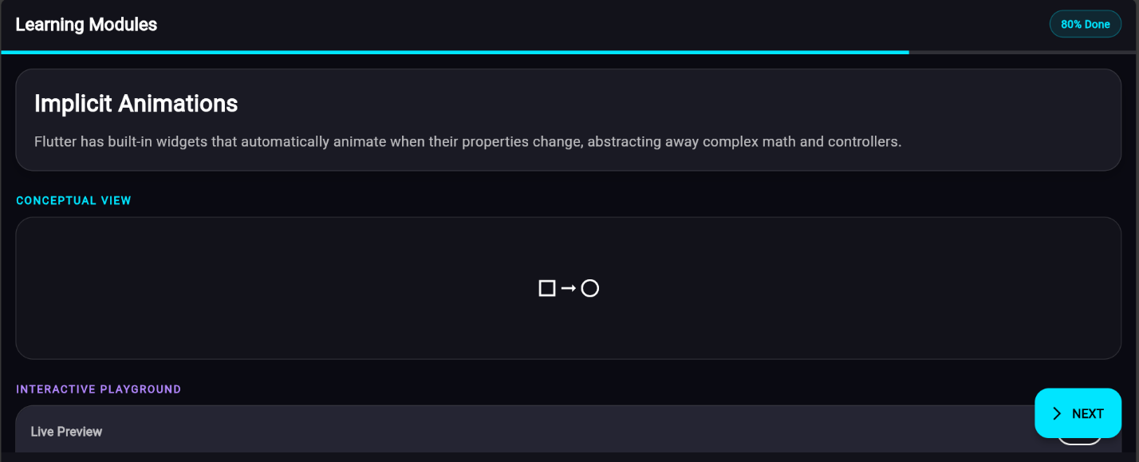
Lesson 04:

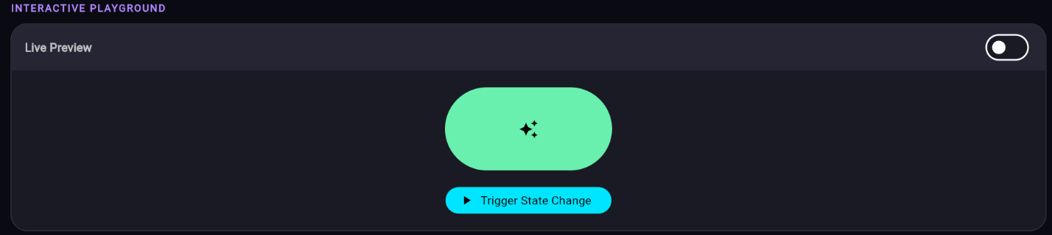
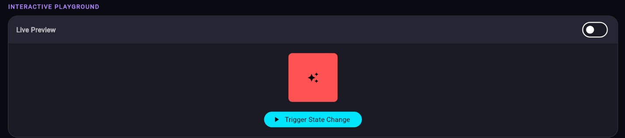

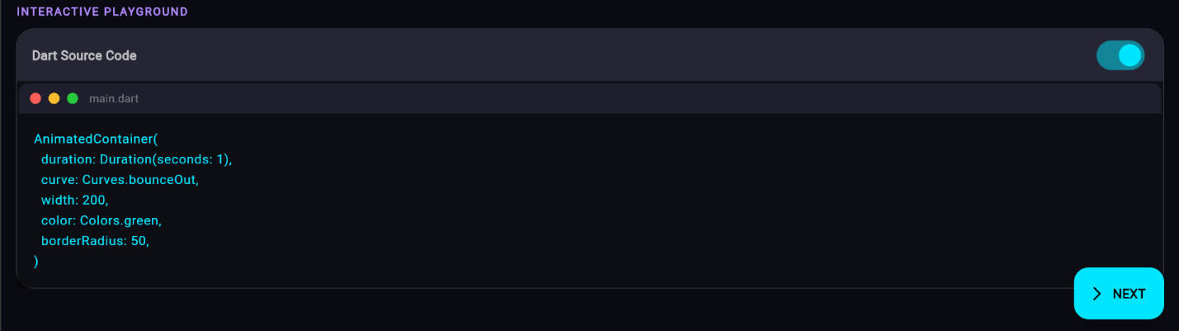

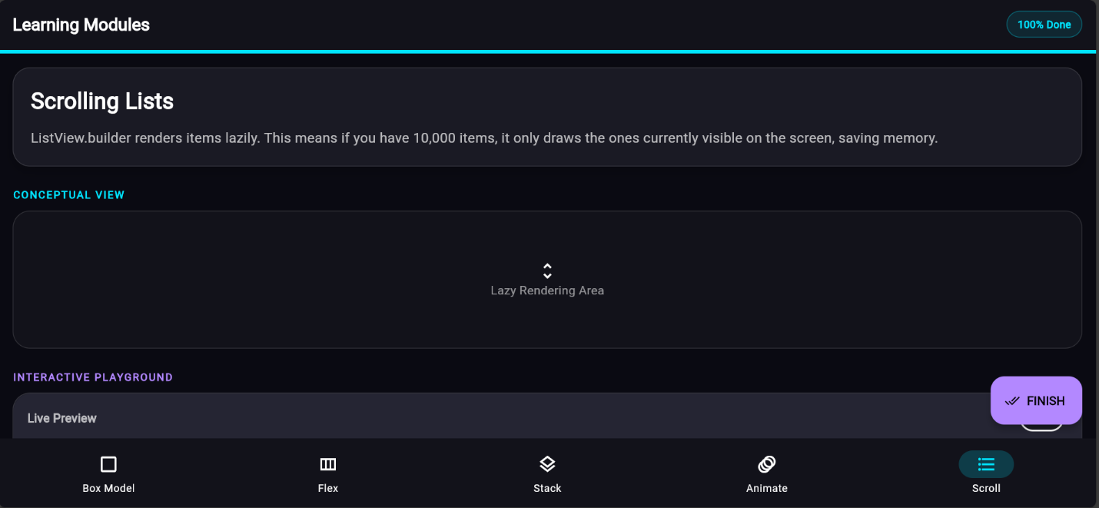
Lesson 05:

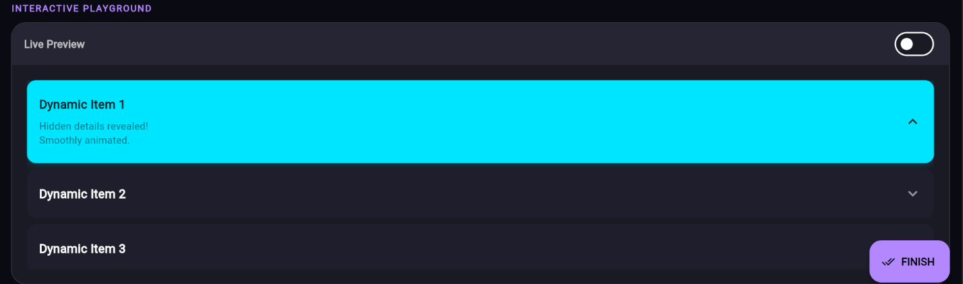

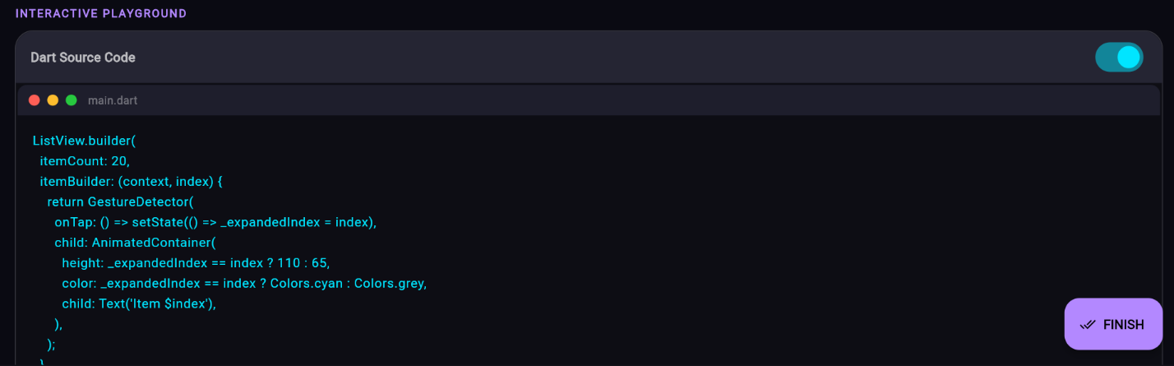

FINISHING COURSE
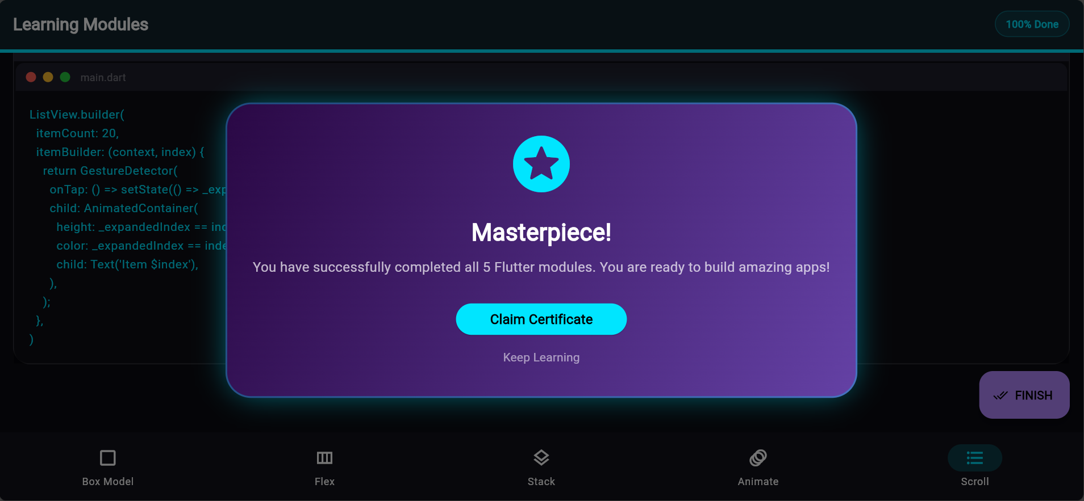
Certificate:
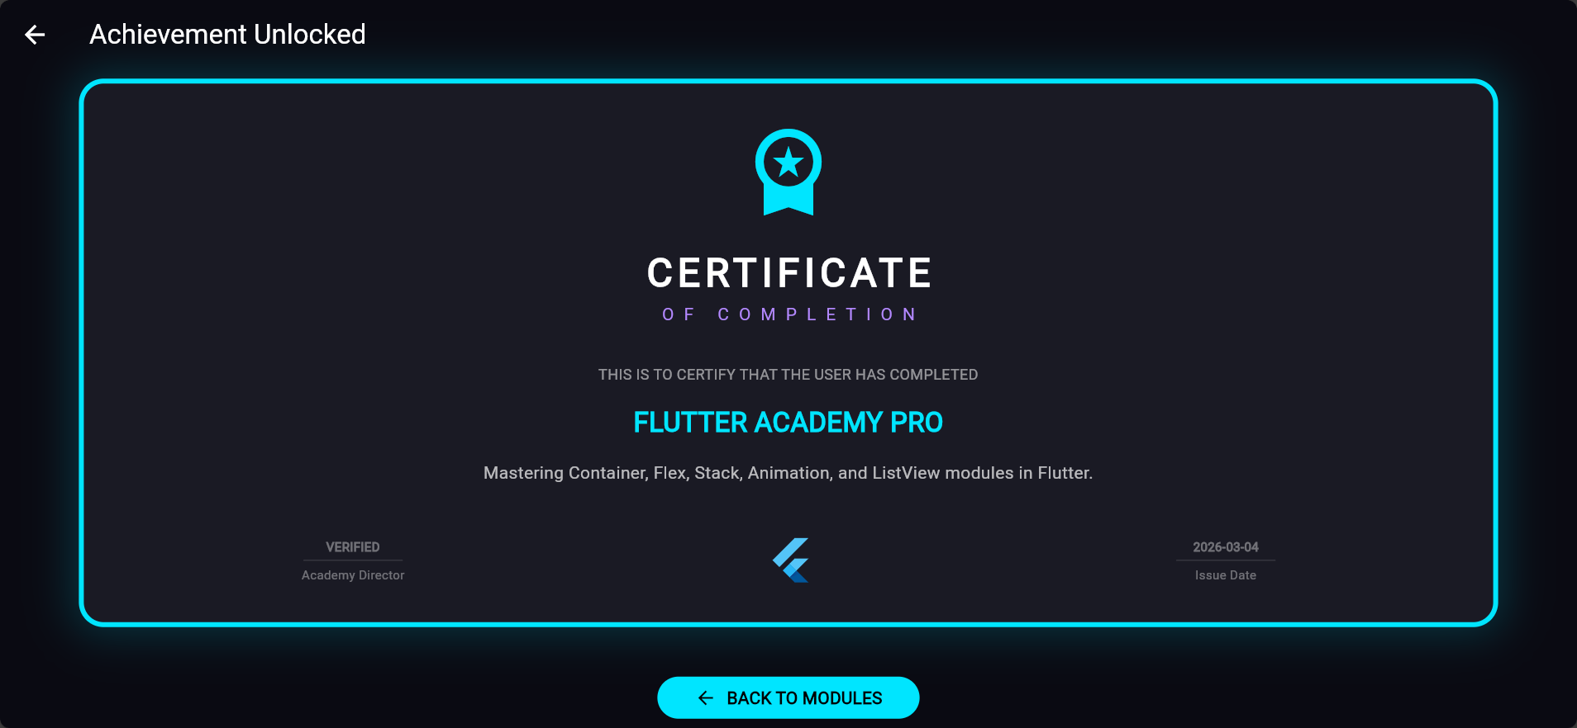

Code:
import 'package:flutter/material.dart';
import 'package:flutter/services.dart';
void main() {
SystemChrome.setSystemUIOverlayStyle(const SystemUiOverlayStyle(
statusBarColor: Colors.transparent,
statusBarIconBrightness: Brightness.light,
));
runApp(const FlutterAcademyApp());
}
class FlutterAcademyApp extends StatelessWidget {
const FlutterAcademyApp({super.key});
@override
Widget build(BuildContext context) {
return MaterialApp(
title: 'Flutter Academy Pro',
debugShowCheckedModeBanner: false,
theme: ThemeData.dark().copyWith(
scaffoldBackgroundColor: const Color(0xFF0A0A12),
colorScheme: const ColorScheme.dark(
primary: Color(0xFF00E5FF),
secondary: Color(0xFFB388FF),
surface: Color(0xFF1A1A24),
),
useMaterial3: true,
),
home: const SplashScreen(),
);
}
}
// ==========================================
// 1. SPLASH SCREEN
// ==========================================
class SplashScreen extends StatefulWidget {
const SplashScreen({super.key});
@override
State<SplashScreen> createState() => _SplashScreenState();
}
class _SplashScreenState extends State<SplashScreen> with SingleTickerProviderStateMixin {
late AnimationController _controller;
late Animation<double> _scaleAnim;
@override
void initState() {
super.initState();
_controller = AnimationController(vsync: this, duration: const Duration(seconds: 2))..repeat(reverse: true);
_scaleAnim = Tween<double>(begin: 0.8, end: 1.1).animate(CurvedAnimation(parent: _controller, curve: Curves.easeInOut));
Future.delayed(const Duration(seconds: 3), () {
if (!mounted) return;
Navigator.pushReplacement(context, PageRouteBuilder(
pageBuilder: (context, anim, secondaryAnim) => const WelcomeScreen(),
transitionsBuilder: (context, anim, secondaryAnim, child) => FadeTransition(opacity: anim, child: child),
transitionDuration: const Duration(milliseconds: 800),
));
});
}
@override
void dispose() {
_controller.dispose();
super.dispose();
}
@override
Widget build(BuildContext context) {
return Scaffold(
body: Container(
decoration: const BoxDecoration(
gradient: RadialGradient(
colors: [Color(0xFF1A1A2E), Color(0xFF0A0A12)],
radius: 1.5,
),
),
child: Center(
child: Column(
mainAxisAlignment: MainAxisAlignment.center,
children: [
ScaleTransition(
scale: _scaleAnim,
child: Hero(
tag: 'app_logo',
child: Container(
padding: const EdgeInsets.all(20),
decoration: BoxDecoration(
shape: BoxShape.circle,
boxShadow: [
BoxShadow(
color: const Color(0xFF00E5FF).withOpacity(0.2),
blurRadius: 40,
spreadRadius: 10,
)
],
),
child: const FlutterLogo(size: 100),
),
),
),
const SizedBox(height: 30),
const Text('Flutter Academy',
style: TextStyle(fontSize: 32, fontWeight: FontWeight.bold, letterSpacing: 2, color: Colors.white)),
const SizedBox(height: 10),
const Text('Interactive Learning Platform',
style: TextStyle(color: Color(0xFF00E5FF), fontSize: 16, letterSpacing: 1.2)),
],
),
),
),
);
}
}
// ==========================================
// 1.5 WELCOME SCREEN
// ==========================================
class WelcomeScreen extends StatelessWidget {
const WelcomeScreen({super.key});
@override
Widget build(BuildContext context) {
return Scaffold(
body: Stack(
children: [
// Background Gradient Circles
Positioned(
top: -100,
right: -100,
child: Container(
width: 300,
height: 300,
decoration: BoxDecoration(
shape: BoxShape.circle,
color: const Color(0xFFB388FF).withOpacity(0.05),
),
),
),
Positioned(
bottom: -50,
left: -50,
child: Container(
width: 200,
height: 200,
decoration: BoxDecoration(
shape: BoxShape.circle,
color: const Color(0xFF00E5FF).withOpacity(0.05),
),
),
),
SafeArea(
child: Padding(
padding: const EdgeInsets.symmetric(horizontal: 30.0),
child: Column(
mainAxisAlignment: MainAxisAlignment.center,
crossAxisAlignment: CrossAxisAlignment.start,
children: [
const Hero(
tag: 'app_logo',
child: FlutterLogo(size: 60),
),
const SizedBox(height: 40),
const Text(
"Master Flutter\nwith Hands-on\nPractice",
style: TextStyle(
fontSize: 42,
fontWeight: FontWeight.bold,
height: 1.1,
color: Colors.white,
),
),
const SizedBox(height: 20),
const Text(
"Experience a new way of learning. Interact with real widgets, tweak properties, and see results instantly.",
style: TextStyle(
fontSize: 18,
color: Colors.white70,
height: 1.5,
),
),
const SizedBox(height: 40),
_buildFeatureTile(Icons.auto_awesome_rounded, "Interactive Playgrounds"),
const SizedBox(height: 12),
_buildFeatureTile(Icons.code_rounded, "Real-time Code View"),
const SizedBox(height: 12),
_buildFeatureTile(Icons.workspace_premium_rounded, "Official Certification"),
const Spacer(),
SizedBox(
width: double.infinity,
height: 65,
child: ElevatedButton(
onPressed: () {
HapticFeedback.mediumImpact();
Navigator.pushReplacement(
context,
MaterialPageRoute(builder: (context) => const MainNavigationScreen()),
);
},
style: ElevatedButton.styleFrom(
backgroundColor: const Color(0xFF00E5FF),
foregroundColor: Colors.black,
shape: RoundedRectangleBorder(
borderRadius: BorderRadius.circular(18),
),
elevation: 10,
shadowColor: const Color(0xFF00E5FF).withOpacity(0.4),
),
child: const Row(
mainAxisAlignment: MainAxisAlignment.center,
children: [
Text(
"Get Started",
style: TextStyle(fontSize: 18, fontWeight: FontWeight.bold),
),
SizedBox(width: 10),
Icon(Icons.arrow_forward_rounded),
],
),
),
),
const SizedBox(height: 40),
],
),
),
),
],
),
);
}
Widget _buildFeatureTile(IconData icon, String text) {
return Row(
children: [
Container(
padding: const EdgeInsets.all(8),
decoration: BoxDecoration(
color: Colors.white.withOpacity(0.05),
borderRadius: BorderRadius.circular(10),
),
child: Icon(icon, color: const Color(0xFFB388FF), size: 20),
),
const SizedBox(width: 15),
Text(text, style: const TextStyle(fontSize: 16, color: Colors.white)),
],
);
}
}
// ==========================================
// 2. MAIN NAVIGATION & PROGRESS
// ==========================================
class MainNavigationScreen extends StatefulWidget {
const MainNavigationScreen({super.key});
@override
State<MainNavigationScreen> createState() => _MainNavigationScreenState();
}
class _MainNavigationScreenState extends State<MainNavigationScreen> {
int _currentIndex = 0;
final Set<int> _visitedLessons = {0};
final List<Widget> _lessons = [
const ContainerLesson(),
const FlexLesson(),
const StackLesson(),
const AnimationLesson(),
const ListViewLesson(),
];
void _onTabTapped(int index) {
HapticFeedback.lightImpact();
setState(() {
_currentIndex = index;
_visitedLessons.add(index);
});
}
void _showGraduationDialog() {
HapticFeedback.heavyImpact();
showDialog(
context: context,
barrierDismissible: false,
builder: (context) {
return Center(
child: TweenAnimationBuilder<double>(
tween: Tween(begin: 0.0, end: 1.0),
duration: const Duration(milliseconds: 800),
curve: Curves.elasticOut,
builder: (context, value, child) {
return Transform.scale(
scale: value,
child: Dialog(
backgroundColor: Colors.transparent,
elevation: 0,
child: Container(
padding: const EdgeInsets.all(30),
decoration: BoxDecoration(
gradient: const LinearGradient(
colors: [Color(0xFF2A0845), Color(0xFF6441A5)],
begin: Alignment.topLeft,
end: Alignment.bottomRight,
),
borderRadius: BorderRadius.circular(30),
boxShadow: [
BoxShadow(color: const Color(0xFF00E5FF).withOpacity(0.5), blurRadius: 30, spreadRadius: -5)
],
border: Border.all(color: const Color(0xFF00E5FF).withOpacity(0.3), width: 2),
),
child: Column(
mainAxisSize: MainAxisSize.min,
children: [
const Icon(Icons.stars_rounded, size: 80, color: Color(0xFF00E5FF)),
const SizedBox(height: 20),
const Text('Masterpiece!',
style: TextStyle(fontSize: 28, fontWeight: FontWeight.bold, color: Colors.white)),
const SizedBox(height: 10),
const Text(
'You have successfully completed all 5 Flutter modules. You are ready to build amazing apps!',
textAlign: TextAlign.center,
style: TextStyle(color: Colors.white70, fontSize: 16, height: 1.5),
),
const SizedBox(height: 30),
ElevatedButton(
style: ElevatedButton.styleFrom(
backgroundColor: const Color(0xFF00E5FF),
foregroundColor: Colors.black,
padding: const EdgeInsets.symmetric(horizontal: 40, vertical: 15),
shape: RoundedRectangleBorder(borderRadius: BorderRadius.circular(20)),
),
onPressed: () {
Navigator.pop(context);
Navigator.push(context, MaterialPageRoute(builder: (context) => const CertificateScreen()));
},
child:
const Text('Claim Certificate', style: TextStyle(fontWeight: FontWeight.bold, fontSize: 16)),
),
const SizedBox(height: 10),
TextButton(
onPressed: () => Navigator.pop(context),
child: const Text('Keep Learning', style: TextStyle(color: Colors.white54)),
)
],
),
),
),
);
},
),
);
},
);
}
@override
Widget build(BuildContext context) {
double progress = _visitedLessons.length / _lessons.length;
bool isLastLesson = _currentIndex == _lessons.length - 1;
return Scaffold(
appBar: AppBar(
title: const Text('Learning Modules', style: TextStyle(fontWeight: FontWeight.bold, fontSize: 20)),
backgroundColor: const Color(0xFF12121A),
centerTitle: false,
actions: [
Container(
margin: const EdgeInsets.only(right: 16),
padding: const EdgeInsets.symmetric(horizontal: 12, vertical: 6),
decoration: BoxDecoration(
color: const Color(0xFF00E5FF).withOpacity(0.1),
borderRadius: BorderRadius.circular(20),
border: Border.all(color: const Color(0xFF00E5FF).withOpacity(0.3)),
),
child: Text(
"${(_visitedLessons.length / _lessons.length * 100).toInt()}% Done",
style: const TextStyle(color: Color(0xFF00E5FF), fontWeight: FontWeight.bold, fontSize: 12),
),
)
],
bottom: PreferredSize(
preferredSize: const Size.fromHeight(6.0),
child: LinearProgressIndicator(
value: progress,
backgroundColor: Colors.white12,
color: const Color(0xFF00E5FF),
minHeight: 4,
),
),
),
body: AnimatedSwitcher(
duration: const Duration(milliseconds: 500),
transitionBuilder: (Widget child, Animation<double> animation) {
return SlideTransition(
position: Tween<Offset>(
begin: const Offset(0.05, 0),
end: Offset.zero,
).animate(CurvedAnimation(parent: animation, curve: Curves.easeOutCubic)),
child: FadeTransition(opacity: animation, child: child),
);
},
child: KeyedSubtree(
key: ValueKey<int>(_currentIndex),
child: _lessons[_currentIndex],
),
),
floatingActionButton: FloatingActionButton.extended(
onPressed: () {
if (isLastLesson) {
_showGraduationDialog();
} else {
_onTabTapped(_currentIndex + 1);
}
},
backgroundColor: isLastLesson ? const Color(0xFFB388FF) : const Color(0xFF00E5FF),
icon: Icon(isLastLesson ? Icons.done_all : Icons.arrow_forward_ios, size: 18, color: Colors.black),
label: Text(isLastLesson ? 'FINISH' : 'NEXT',
style: const TextStyle(color: Colors.black, fontWeight: FontWeight.bold)),
),
bottomNavigationBar: NavigationBar(
selectedIndex: _currentIndex,
onDestinationSelected: _onTabTapped,
backgroundColor: const Color(0xFF12121A),
indicatorColor: const Color(0xFF00E5FF).withOpacity(0.2),
destinations: const [
NavigationDestination(
icon: Icon(Icons.check_box_outline_blank),
selectedIcon: Icon(Icons.check_box, color: Color(0xFF00E5FF)),
label: 'Box Model'),
NavigationDestination(
icon: Icon(Icons.view_column_outlined),
selectedIcon: Icon(Icons.view_column, color: Color(0xFF00E5FF)),
label: 'Flex'),
NavigationDestination(
icon: Icon(Icons.layers_outlined),
selectedIcon: Icon(Icons.layers, color: Color(0xFF00E5FF)),
label: 'Stack'),
NavigationDestination(
icon: Icon(Icons.animation),
selectedIcon: Icon(Icons.auto_awesome, color: Color(0xFF00E5FF)),
label: 'Animate'),
NavigationDestination(
icon: Icon(Icons.list),
selectedIcon: Icon(Icons.format_list_bulleted, color: Color(0xFF00E5FF)),
label: 'Scroll'),
],
),
);
}
}
// ==========================================
// 3. REUSABLE UI COMPONENTS
// ==========================================
class LessonLayout extends StatelessWidget {
final String title;
final String description;
final Widget customDiagram;
final Widget playground;
final String codeSnippet;
const LessonLayout(
{super.key,
required this.title,
required this.description,
required this.customDiagram,
required this.playground,
required this.codeSnippet});
@override
Widget build(BuildContext context) {
return ListView(
padding: const EdgeInsets.only(left: 16.0, right: 16.0, top: 16.0, bottom: 80.0),
children: [
// THEORY CARD
Container(
padding: const EdgeInsets.all(20),
decoration: BoxDecoration(
color: const Color(0xFF1A1A24),
borderRadius: BorderRadius.circular(20),
border: Border.all(color: Colors.white12),
boxShadow: [
BoxShadow(
color: Colors.black.withOpacity(0.2),
blurRadius: 10,
offset: const Offset(0, 5),
)
],
),
child: Column(
crossAxisAlignment: CrossAxisAlignment.start,
children: [
Text(title, style: const TextStyle(fontSize: 26, fontWeight: FontWeight.bold, color: Colors.white)),
const SizedBox(height: 12),
Text(description, style: const TextStyle(color: Colors.white70, fontSize: 16, height: 1.5)),
],
),
),
const SizedBox(height: 24),
// VISUAL DIAGRAM
const Text('CONCEPTUAL VIEW',
style: TextStyle(color: Color(0xFF00E5FF), fontWeight: FontWeight.bold, letterSpacing: 1.5, fontSize: 12)),
const SizedBox(height: 10),
Container(
height: 160,
decoration: BoxDecoration(
color: const Color(0xFF12121A), borderRadius: BorderRadius.circular(20), border: Border.all(color: Colors.white12)),
child: Center(child: customDiagram),
),
const SizedBox(height: 24),
// PLAYGROUND WITH CODE TOGGLE
const Text('INTERACTIVE PLAYGROUND',
style: TextStyle(color: Color(0xFFB388FF), fontWeight: FontWeight.bold, letterSpacing: 1.5, fontSize: 12)),
const SizedBox(height: 10),
PlaygroundWithCode(playground: playground, codeSnippet: codeSnippet),
],
);
}
}
class PlaygroundWithCode extends StatefulWidget {
final Widget playground;
final String codeSnippet;
const PlaygroundWithCode({super.key, required this.playground, required this.codeSnippet});
@override
State<PlaygroundWithCode> createState() => _PlaygroundWithCodeState();
}
class _PlaygroundWithCodeState extends State<PlaygroundWithCode> {
bool _showCode = false;
@override
Widget build(BuildContext context) {
return Container(
decoration: BoxDecoration(
color: const Color(0xFF1A1A24), borderRadius: BorderRadius.circular(20), border: Border.all(color: Colors.white12)),
child: Column(
children: [
Container(
padding: const EdgeInsets.symmetric(horizontal: 16, vertical: 8),
decoration: const BoxDecoration(color: Color(0xFF252533), borderRadius: BorderRadius.vertical(top: Radius.circular(20))),
child: Row(
mainAxisAlignment: MainAxisAlignment.spaceBetween,
children: [
Text(_showCode ? 'Dart Source Code' : 'Live Preview',
style: const TextStyle(color: Colors.white70, fontWeight: FontWeight.bold)),
Switch(
value: _showCode,
activeColor: const Color(0xFF00E5FF),
onChanged: (val) {
HapticFeedback.selectionClick();
setState(() => _showCode = val);
},
),
],
),
),
AnimatedCrossFade(
duration: const Duration(milliseconds: 300),
crossFadeState: _showCode ? CrossFadeState.showSecond : CrossFadeState.showFirst,
firstChild: Padding(padding: const EdgeInsets.all(20), child: widget.playground),
secondChild: Container(
width: double.infinity,
padding: const EdgeInsets.all(2),
color: Colors.black45,
child: Column(
crossAxisAlignment: CrossAxisAlignment.start,
children: [
Container(
padding: const EdgeInsets.symmetric(horizontal: 12, vertical: 8),
decoration: const BoxDecoration(
color: Color(0xFF1E1E2C),
borderRadius: BorderRadius.only(topLeft: Radius.circular(10), topRight: Radius.circular(10))),
child: Row(
children: [
Container(
width: 12, height: 12, decoration: const BoxDecoration(color: Color(0xFFFF5F56), shape: BoxShape.circle)),
const SizedBox(width: 8),
Container(
width: 12, height: 12, decoration: const BoxDecoration(color: Color(0xFFFFBD2E), shape: BoxShape.circle)),
const SizedBox(width: 8),
Container(
width: 12, height: 12, decoration: const BoxDecoration(color: Color(0xFF27C93F), shape: BoxShape.circle)),
const SizedBox(width: 12),
const Text('main.dart', style: TextStyle(color: Colors.white38, fontSize: 12, fontFamily: 'monospace')),
],
),
),
Container(
width: double.infinity,
padding: const EdgeInsets.all(16),
decoration: const BoxDecoration(
color: Color(0xFF0D0D14),
borderRadius: BorderRadius.only(bottomLeft: Radius.circular(10), bottomRight: Radius.circular(10))),
child: Text(widget.codeSnippet,
style: const TextStyle(
fontFamily: 'monospace',
color: Color(0xFF00E5FF),
fontSize: 14,
height: 1.6,
letterSpacing: 0.5,
)),
),
],
),
),
)
],
),
);
}
}
// ==========================================
// 4. THE 5 INTERACTIVE LESSONS
// ==========================================
class ContainerLesson extends StatefulWidget {
const ContainerLesson({super.key});
@override
State<ContainerLesson> createState() => _ContainerLessonState();
}
class _ContainerLessonState extends State<ContainerLesson> {
double _padding = 10;
@override
Widget build(BuildContext context) {
return LessonLayout(
title: 'The Box Model',
description:
'The Container widget combines painting, positioning, and sizing. It follows the Box Model: Margin (outside), Border, Padding (inside), and Content.',
customDiagram: Container(
padding: const EdgeInsets.all(15),
color: Colors.blue.withOpacity(0.2),
child: const Text('Margin', style: TextStyle(color: Colors.blue)),
),
playground: Column(
children: [
AnimatedContainer(
duration: const Duration(milliseconds: 300),
padding: EdgeInsets.all(_padding),
decoration: BoxDecoration(color: const Color(0xFF00E5FF), border: Border.all(color: Colors.white, width: 2)),
child: Container(
color: Colors.black54,
padding: const EdgeInsets.all(20),
child: const Text('CONTENT', style: TextStyle(fontWeight: FontWeight.bold))),
),
Slider(
value: _padding,
min: 0,
max: 40,
activeColor: const Color(0xFF00E5FF),
onChanged: (v) => setState(() => _padding = v)),
const Text('Adjust Padding', style: TextStyle(color: Colors.white54))
],
),
codeSnippet:
"AnimatedContainer(\n padding: EdgeInsets.all($_padding),\n decoration: BoxDecoration(\n color: Colors.cyan,\n ),\n child: Text('CONTENT'),\n)",
);
}
}
class FlexLesson extends StatefulWidget {
const FlexLesson({super.key});
@override
State<FlexLesson> createState() => _FlexLessonState();
}
class _FlexLessonState extends State<FlexLesson> {
MainAxisAlignment _alignment = MainAxisAlignment.spaceEvenly;
@override
Widget build(BuildContext context) {
return LessonLayout(
title: 'Flex Layouts',
description:
'Row and Column widgets arrange children linearly. You use properties like MainAxisAlignment to distribute empty space along the primary axis.',
customDiagram: const Row(
mainAxisAlignment: MainAxisAlignment.center,
children: [
Icon(Icons.arrow_forward, color: Colors.white54),
SizedBox(width: 10),
Text('Main Axis (Row) ->', style: TextStyle(fontWeight: FontWeight.bold))
],
),
playground: Column(
children: [
Container(
height: 80,
color: Colors.black26,
child: AnimatedContainer(
duration: const Duration(milliseconds: 300),
child: Row(
mainAxisAlignment: _alignment,
children: [
Container(width: 40, height: 40, color: Colors.pinkAccent),
Container(width: 40, height: 40, color: Colors.amberAccent),
Container(width: 40, height: 40, color: Colors.lightGreenAccent),
],
),
),
),
const SizedBox(height: 15),
Wrap(
spacing: 10,
children: [MainAxisAlignment.start, MainAxisAlignment.center, MainAxisAlignment.spaceEvenly].map((align) {
return ChoiceChip(
label: Text(align.name),
selected: _alignment == align,
onSelected: (val) {
HapticFeedback.selectionClick();
setState(() => _alignment = align);
},
);
}).toList(),
)
],
),
codeSnippet:
"Row(\n mainAxisAlignment: MainAxisAlignment.${_alignment.name},\n children: [\n WidgetA(), WidgetB(), WidgetC()\n ],\n)",
);
}
}
class StackLesson extends StatefulWidget {
const StackLesson({super.key});
@override
State<StackLesson> createState() => _StackLessonState();
}
class _StackLessonState extends State<StackLesson> {
bool _moved = false;
@override
Widget build(BuildContext context) {
return LessonLayout(
title: 'Z-Axis & Stack',
description:
'The Stack widget allows you to overlap widgets. The first child is at the bottom. Use Positioned to pin children to specific coordinates.',
customDiagram: const Stack(
alignment: Alignment.center,
children: [
Icon(Icons.layers, size: 80, color: Colors.white24),
Text('Z-Axis ↑', style: TextStyle(color: Color(0xFFB388FF), fontWeight: FontWeight.bold)),
],
),
playground: SizedBox(
height: 200,
child: Stack(
children: [
Container(decoration: BoxDecoration(color: Colors.black26, borderRadius: BorderRadius.circular(15))),
const Center(child: Text('Base Layer')),
AnimatedPositioned(
duration: const Duration(milliseconds: 500),
curve: Curves.elasticOut,
top: _moved ? 120 : 20,
left: _moved ? 200 : 20,
child: GestureDetector(
onTap: () {
HapticFeedback.lightImpact();
setState(() => _moved = !_moved);
},
child: Container(
width: 60,
height: 60,
decoration: BoxDecoration(color: const Color(0xFFB388FF), borderRadius: BorderRadius.circular(10)),
child: const Icon(Icons.touch_app, color: Colors.black)),
),
),
],
),
),
codeSnippet:
"Stack(\n children: [\n BaseWidget(),\n AnimatedPositioned(\n top: ${_moved ? 120 : 20},\n left: ${_moved ? 200 : 20},\n child: DraggableWidget(),\n ),\n ],\n)",
);
}
}
class AnimationLesson extends StatefulWidget {
const AnimationLesson({super.key});
@override
State<AnimationLesson> createState() => _AnimationLessonState();
}
class _AnimationLessonState extends State<AnimationLesson> {
bool _isMorphed = false;
@override
Widget build(BuildContext context) {
return LessonLayout(
title: 'Implicit Animations',
description:
'Flutter has built-in widgets that automatically animate when their properties change, abstracting away complex math and controllers.',
customDiagram: const Row(
mainAxisAlignment: MainAxisAlignment.center,
children: [Icon(Icons.square_outlined), Icon(Icons.arrow_right_alt), Icon(Icons.circle_outlined)]),
playground: Column(
children: [
AnimatedContainer(
duration: const Duration(seconds: 1),
curve: Curves.bounceOut,
width: _isMorphed ? 200 : 100,
height: 100,
decoration: BoxDecoration(
color: _isMorphed ? Colors.greenAccent : Colors.redAccent,
borderRadius: BorderRadius.circular(_isMorphed ? 50 : 8),
),
child: const Center(child: Icon(Icons.auto_awesome, color: Colors.black)),
),
const SizedBox(height: 20),
ElevatedButton.icon(
icon: const Icon(Icons.play_arrow, color: Colors.black),
label: const Text('Trigger State Change', style: TextStyle(color: Colors.black)),
style: ElevatedButton.styleFrom(backgroundColor: const Color(0xFF00E5FF)),
onPressed: () {
HapticFeedback.heavyImpact();
setState(() => _isMorphed = !_isMorphed);
},
)
],
),
codeSnippet:
"AnimatedContainer(\n duration: Duration(seconds: 1),\n curve: Curves.bounceOut,\n width: ${_isMorphed ? 200 : 100},\n color: ${_isMorphed ? 'Colors.green' : 'Colors.red'},\n borderRadius: ${_isMorphed ? 50 : 8},\n)",
);
}
}
class ListViewLesson extends StatefulWidget {
const ListViewLesson({super.key});
@override
State<ListViewLesson> createState() => _ListViewLessonState();
}
class _ListViewLessonState extends State<ListViewLesson> {
int? _expandedIndex;
@override
Widget build(BuildContext context) {
return LessonLayout(
title: 'Scrolling Lists',
description:
'ListView.builder renders items lazily. This means if you have 10,000 items, it only draws the ones currently visible on the screen, saving memory.',
customDiagram: const Column(
mainAxisAlignment: MainAxisAlignment.center,
children: [Icon(Icons.unfold_more), Text('Lazy Rendering Area', style: TextStyle(color: Colors.white54))]),
playground: SizedBox(
height: 250,
child: ListView.builder(
itemCount: 20,
itemBuilder: (context, index) {
final isExpanded = _expandedIndex == index;
return GestureDetector(
onTap: () {
HapticFeedback.selectionClick();
setState(() {
_expandedIndex = isExpanded ? null : index;
});
},
child: AnimatedContainer(
duration: const Duration(milliseconds: 300),
curve: Curves.easeInOutCubic,
margin: const EdgeInsets.only(bottom: 8),
padding: const EdgeInsets.symmetric(horizontal: 16),
height: isExpanded ? 110 : 65,
decoration: BoxDecoration(
color: isExpanded ? const Color(0xFF00E5FF) : const Color(0xFF1E1E2C),
borderRadius: BorderRadius.circular(12),
boxShadow: isExpanded ? [BoxShadow(color: const Color(0xFF00E5FF).withOpacity(0.3), blurRadius: 10)] : [],
),
child: Row(
mainAxisAlignment: MainAxisAlignment.spaceBetween,
children: [
Column(
mainAxisAlignment: MainAxisAlignment.center,
crossAxisAlignment: CrossAxisAlignment.start,
children: [
Text('Dynamic Item ${index + 1}',
style: TextStyle(
color: isExpanded ? Colors.black87 : Colors.white,
fontWeight: FontWeight.bold,
fontSize: 16,
)),
if (isExpanded) ...[
const SizedBox(height: 8),
const Text(
'Hidden details revealed!\nSmoothly animated.',
style: TextStyle(color: Colors.black54, fontSize: 13),
)
]
],
),
Icon(isExpanded ? Icons.keyboard_arrow_up : Icons.keyboard_arrow_down,
color: isExpanded ? Colors.black87 : Colors.white54),
],
),
),
);
},
),
),
codeSnippet:
"ListView.builder(\n itemCount: 20,\n itemBuilder: (context, index) {\n return GestureDetector(\n onTap: () => setState(() => _expandedIndex = index),\n child: AnimatedContainer(\n height: _expandedIndex == index ? 110 : 65,\n color: _expandedIndex == index ? Colors.cyan : Colors.grey,\n child: Text('Item \$index'),\n ),\n );\n },\n)",
);
}
}
// ==========================================
// 5. CERTIFICATE SCREEN
// ==========================================
class CertificateScreen extends StatelessWidget {
const CertificateScreen({super.key});
@override
Widget build(BuildContext context) {
return Scaffold(
backgroundColor: const Color(0xFF0A0A12),
appBar: AppBar(
title: const Text('Achievement Unlocked'),
backgroundColor: Colors.transparent,
elevation: 0,
),
body: Center(
child: SingleChildScrollView(
child: Column(
mainAxisAlignment: MainAxisAlignment.center,
children: [
Container(
width: MediaQuery.of(context).size.width * 0.9,
padding: const EdgeInsets.all(30),
decoration: BoxDecoration(
color: const Color(0xFF1A1A24),
borderRadius: BorderRadius.circular(20),
border: Border.all(color: const Color(0xFF00E5FF), width: 4),
boxShadow: [BoxShadow(color: const Color(0xFF00E5FF).withOpacity(0.2), blurRadius: 30, spreadRadius: 5)],
),
child: Column(
children: [
const Icon(Icons.workspace_premium, size: 80, color: Color(0xFF00E5FF)),
const SizedBox(height: 20),
const Text(
'CERTIFICATE',
style: TextStyle(fontSize: 32, fontWeight: FontWeight.bold, letterSpacing: 4, color: Colors.white),
),
const Text(
'OF COMPLETION',
style: TextStyle(fontSize: 14, fontWeight: FontWeight.w300, letterSpacing: 8, color: Color(0xFFB388FF)),
),
const SizedBox(height: 30),
const Text(
'THIS IS TO CERTIFY THAT THE USER HAS COMPLETED',
textAlign: TextAlign.center,
style: TextStyle(fontSize: 12, color: Colors.white54),
),
const SizedBox(height: 15),
const Text(
'FLUTTER ACADEMY PRO',
style: TextStyle(fontSize: 22, fontWeight: FontWeight.bold, color: Color(0xFF00E5FF)),
),
const SizedBox(height: 15),
const Text(
'Mastering Container, Flex, Stack, Animation, and ListView modules in Flutter.',
textAlign: TextAlign.center,
style: TextStyle(fontSize: 14, color: Colors.white70, height: 1.5),
),
const SizedBox(height: 40),
Row(
mainAxisAlignment: MainAxisAlignment.spaceAround,
children: [
Column(
children: [
const Text('VERIFIED',
style: TextStyle(fontWeight: FontWeight.bold, fontSize: 10, color: Colors.white38)),
Container(
height: 1,
width: 80,
color: Colors.white12,
margin: const EdgeInsets.symmetric(vertical: 4)),
const Text('Academy Director', style: TextStyle(fontSize: 10, color: Colors.white38)),
],
),
const FlutterLogo(size: 40),
Column(
children: [
Text(DateTime.now().toString().split(' ')[0],
style: const TextStyle(fontWeight: FontWeight.bold, fontSize: 10, color: Colors.white38)),
Container(
height: 1,
width: 80,
color: Colors.white12,
margin: const EdgeInsets.symmetric(vertical: 4)),
const Text('Issue Date', style: TextStyle(fontSize: 10, color: Colors.white38)),
],
),
],
),
],
),
),
const SizedBox(height: 40),
ElevatedButton.icon(
onPressed: () => Navigator.pop(context),
icon: const Icon(Icons.arrow_back, color: Colors.black),
label: const Text('BACK TO MODULES', style: TextStyle(color: Colors.black, fontWeight: FontWeight.bold)),
style: ElevatedButton.styleFrom(
backgroundColor: const Color(0xFF00E5FF),
padding: const EdgeInsets.symmetric(horizontal: 30, vertical: 15),
shape: RoundedRectangleBorder(borderRadius: BorderRadius.circular(30)),
),
),
],
),
),
),
);
}
}

